# CS 255 System Design Document Template

This template lays out all the different sections that you need to complete for Project Two. Each section has guidance to prompt your thinking. You will need to continually reference the interview transcript as you work to make sure that you are addressing your client’s needs. There is no required length for the final document. Instead the goal is to complete each section based on what your client’s needs are. Remove this note when you are finished, and replace all bracketed text with the relevant information.

Darren Sheftic

## UML Diagrams

### UML Use Case Diagram

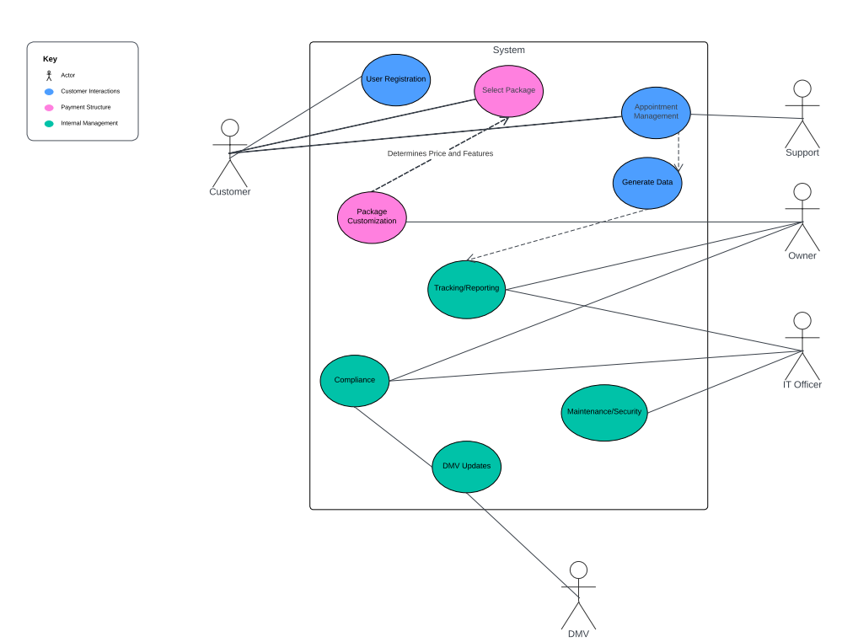

### UML Activity Diagrams

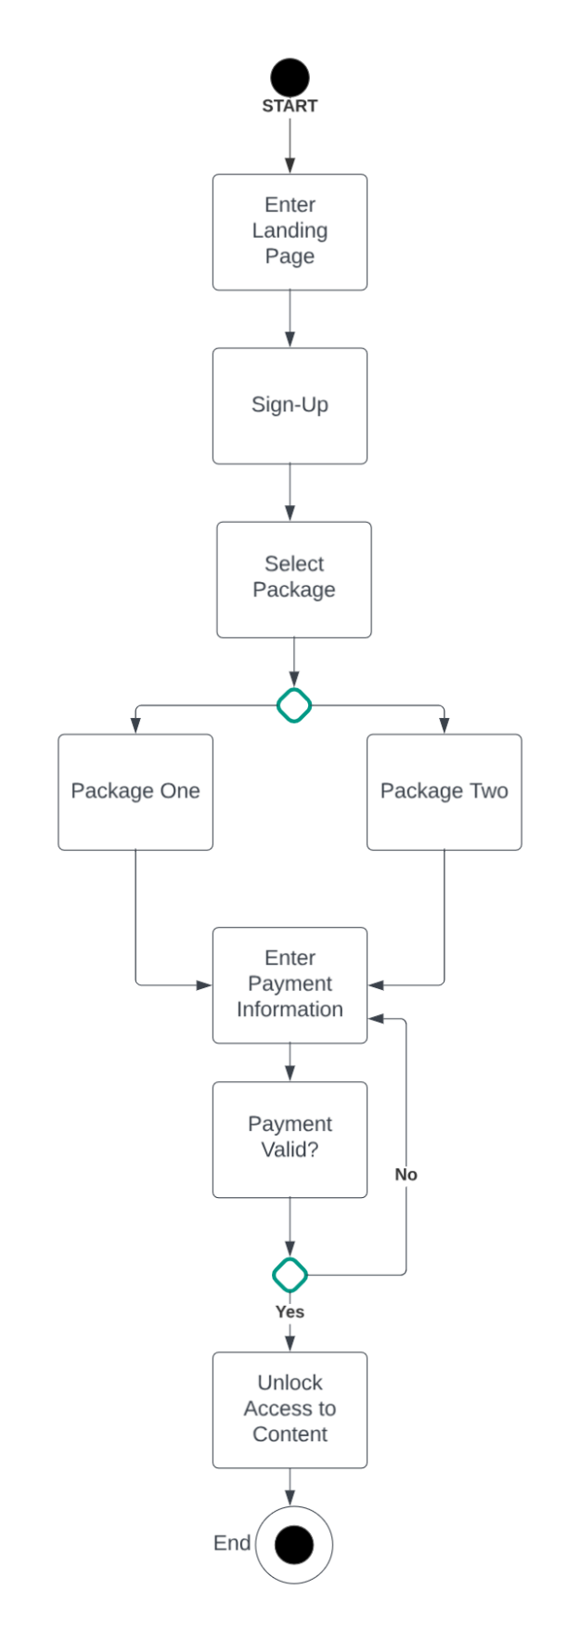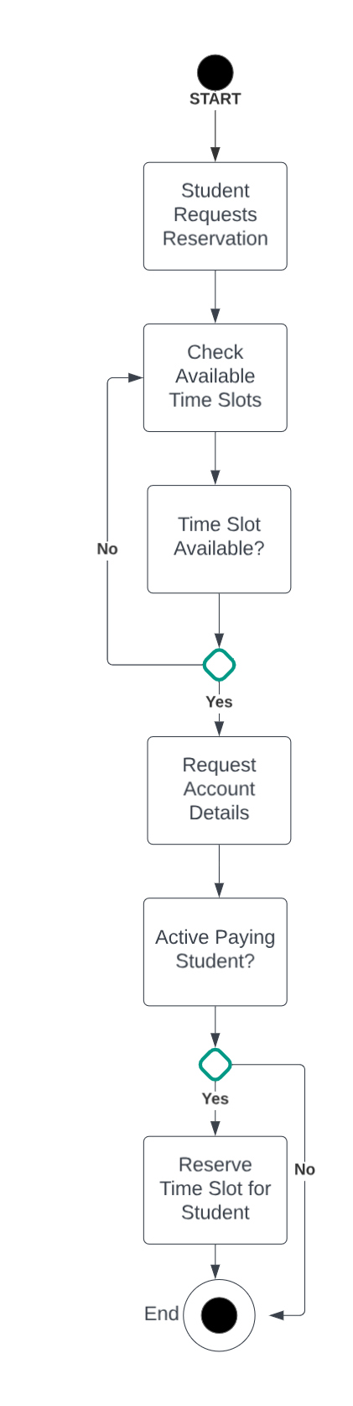

### UML Sequence Diagram

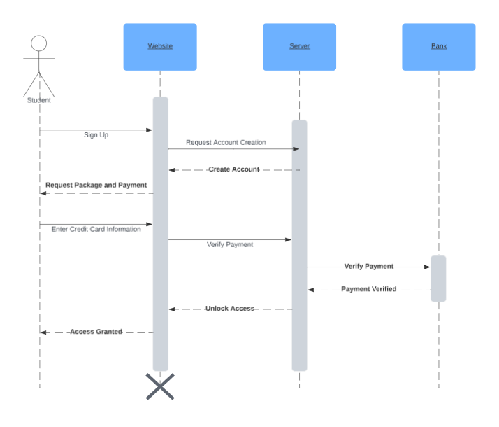

### UML Class Diagram

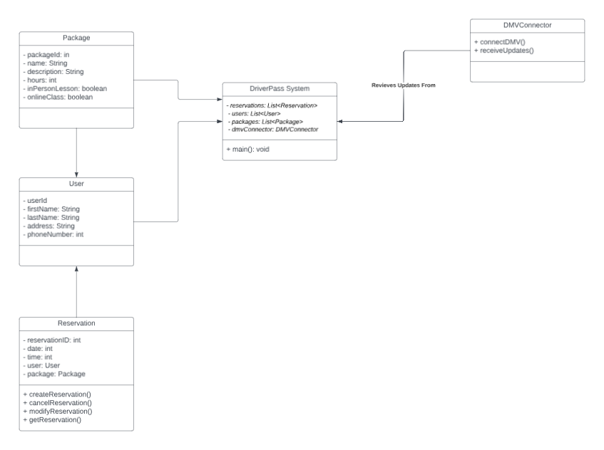

## Technical Requirements

**Hardware:**

Mobile Devices

Web Server and Database

**Software:**

Mobile App Platforms

*Apple*

*Android*

Web Based Browsers

*Google Chrome*

*Mozilla Firefox*

*Apple Safari*

SQL Database Management System

Web Hosting Service

**Development Tools:**

Professional Suite IDE

**Infrastructure:**

Security

Backup/Recovery